Personal Expense Tracker Technology Architecture

Team ID : PNT2022TMID15737

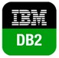

Kubernetes Cluster

Cloud Services

Application

User System

User

Internet



